## 

## **Experiment-4**

**Student Name:** Gauri Prabhakar **UID:** 18BCS6201

**Branch:** 18AITAIML-2 **Section/Group:** B

**Semester:** 7 **Date of Performance:** 8th September, 2021

**Subject Name:** Advanced Database Management Lab **Subject Code:** CSP - 434

# Aim/Overview of the practical:

To create and perform queries on sequences, synonyms and views.

# Task to be done:

To create and perform queries on sequences, synonyms and views.

# Steps to be followed:

**Creating a SEQUENCE, incrementing it by 1 then creating a table and inserting values into the table and setting NEXTVAL:**

# CREATE SEQUENCE STUDENT_ID START WITH 151 INCREMENT BY 1 NOCACHE NOCYCLE;

# CREATE TABLE STUDENT(Roll_No int, Name varchar(50), Age int);

# INSERT INTO STUDENT VALUES(STUDENT_ID.NEXTVAL,'Gauri',21);

# INSERT INTO STUDENT VALUES(STUDENT_ID.NEXTVAL,'Lilly',22);

# INSERT INTO STUDENT VALUES(STUDENT_ID.NEXTVAL,'Rose',18);

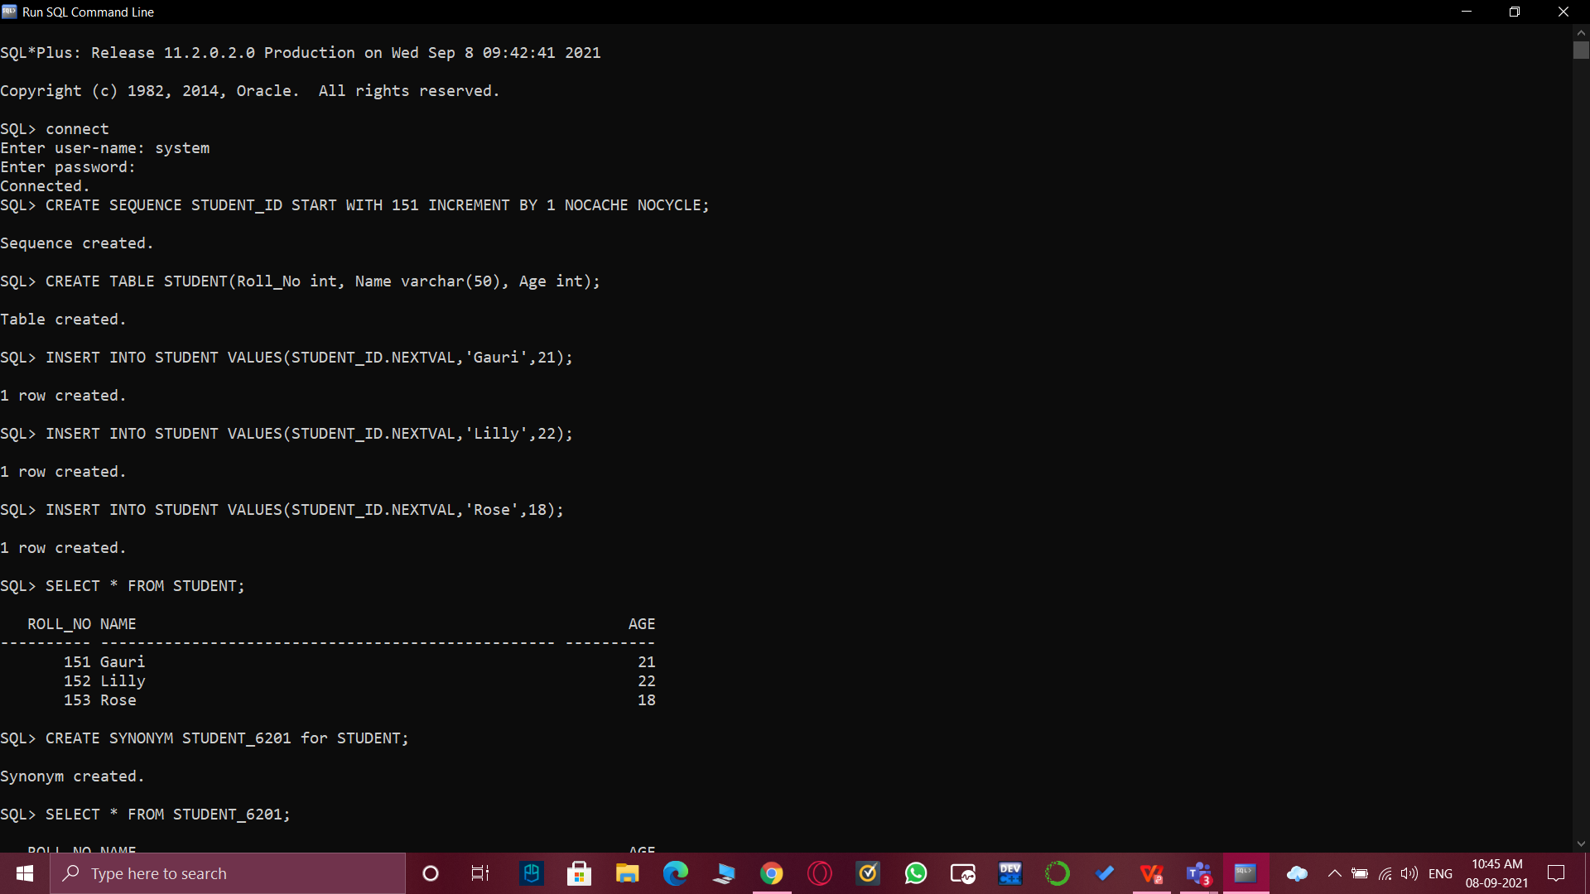

**Returning the table and creating SYNONYM:**

1. SELECT * FROM STUDENT;



**Returning the SYNONYM table and inserting value to the original table and then returning the original table:**

1. CREATE SYNONYM STUDENT_6201 for STUDENT;

SELECT * FROM STUDENT_6201;

INSERT INTO STUDENT VALUES(STUDENT_ID.NEXTVAL,'Chelsea',24);

SELECT * FROM STUDENT;

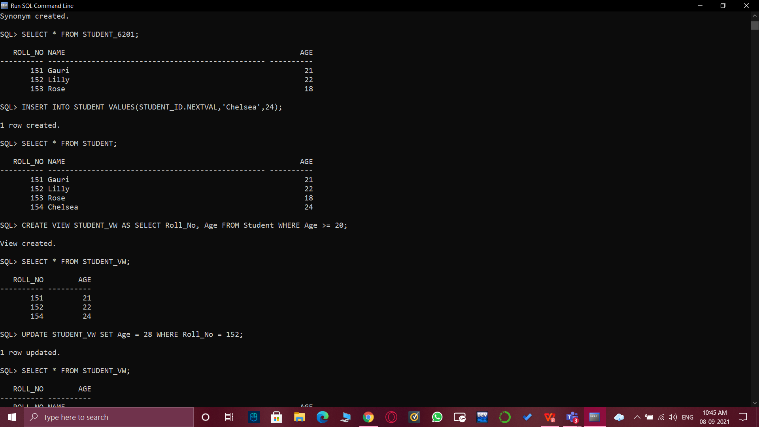

**Creating a VIEW then returning it then UPDATING the VIEW:**

1. CREATE VIEW STUDENT_VW AS SELECT Roll_No, Age FROM Student WHERE Age >= 20;

SELECT * FROM STUDENT_VW;

UPDATE STUDENT_VW SET Age = 28 WHERE Roll_No = 152;



**Returning the updated VIEW, creating another VIEW from the previous VIEW, returning the new VIEW and then inserting values into the new VIEW and returning the updated view:**

1. SELECT * FROM STUDENT_VW;

CREATE VIEW STUDENT_VEW AS SELECT Roll_No, Age FROM STUDENT_VW;

SELECT * FROM STUDENT_VEW;

INSERT INTO STUDENT_VEW VALUES (STUDENT_ID.NEXTVAL, 26);

SELECT * FROM STUDENT_VEW;

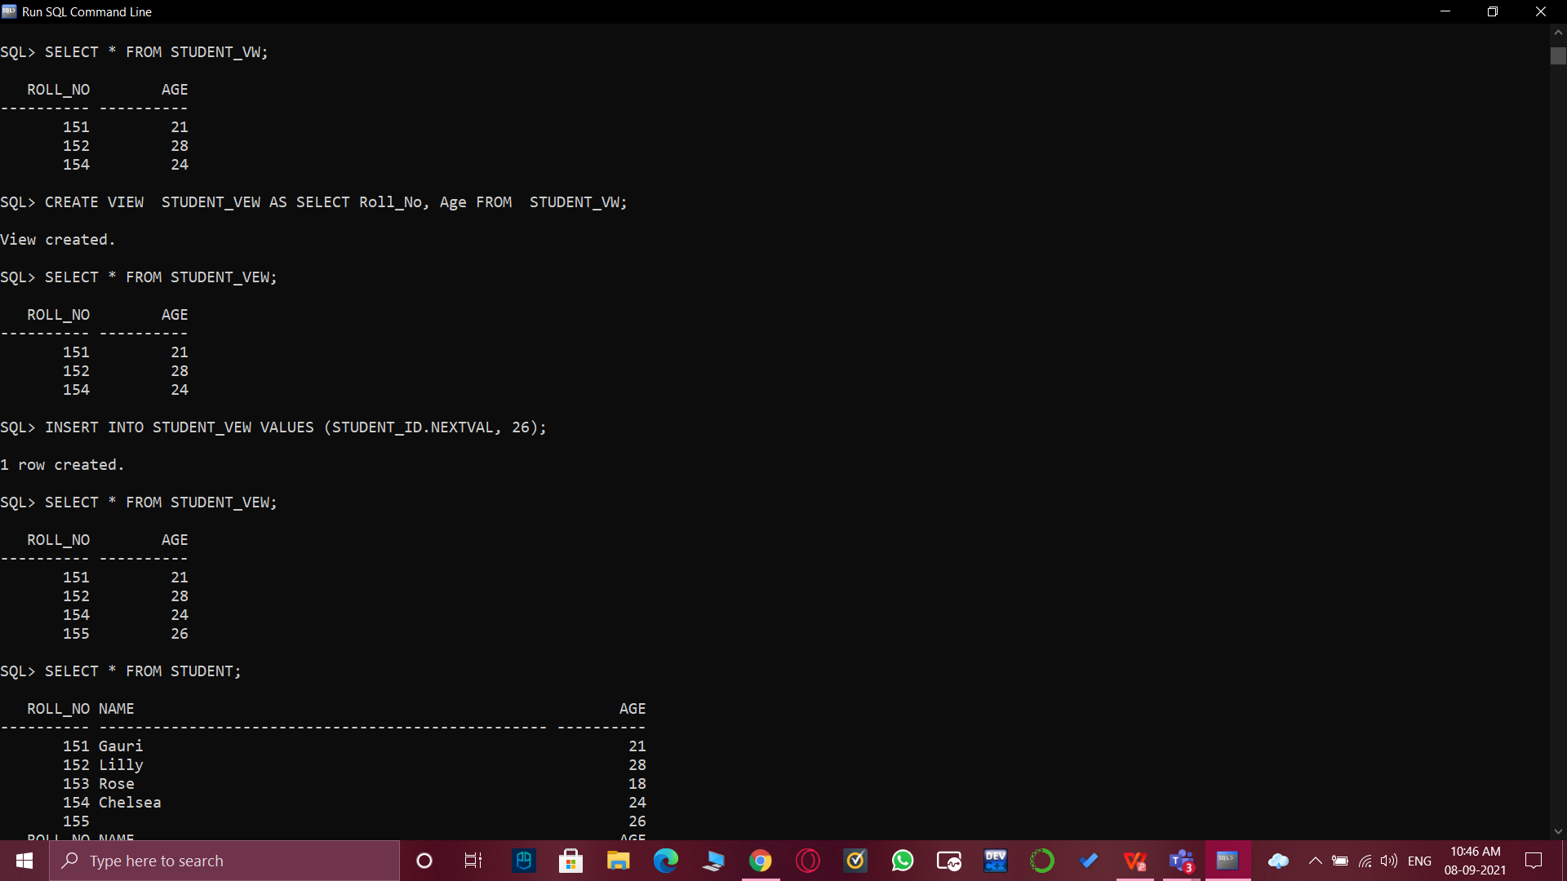

**Returning the updated table and then DROPPING the view:**

1. SELECT * FROM STUDENT;

DROP VIEW STUDENT_VW;

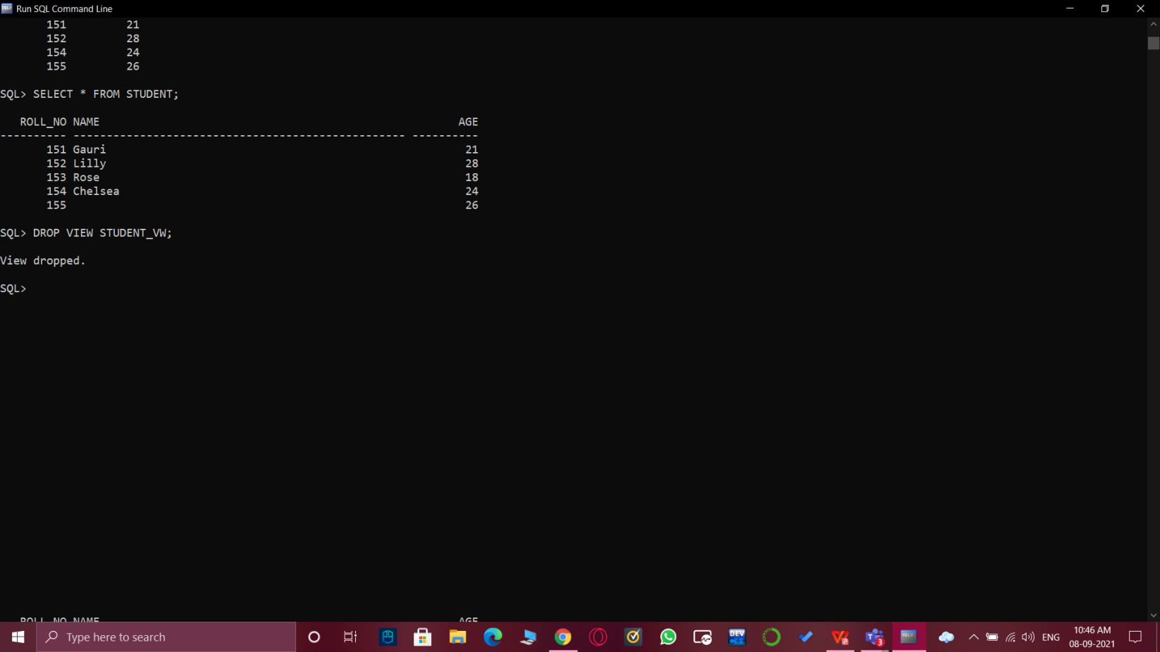

1. **Result/Output/Writing Summary:**

* Successfully implemented Sequence, Synonym and Views.
* Successfully understood the functioning and importance of the above mentioned.
* Successfully implemented operations on the above mentioned.
* Successfully understood the working of Sequence, Synonym and Views .

# Learning outcomes (What I have learnt):

* How to implement Sequence, Synonym and Views on SQL Command Line.
* How to update Views and initialize Sequence.
* How to implement operations on Sequence, Synonym and Views and return their outcomes.

**Evaluation Grid (To be created as per the SOP and Assessment guidelines by the faculty):**

|  |  |  |  |
| --- | --- | --- | --- |
| Sr. No. | Parameters | Marks Obtained | Maximum Marks |
| 1. |  |  |  |
| 2. |  |  |  |
| 3. |  |  |  |